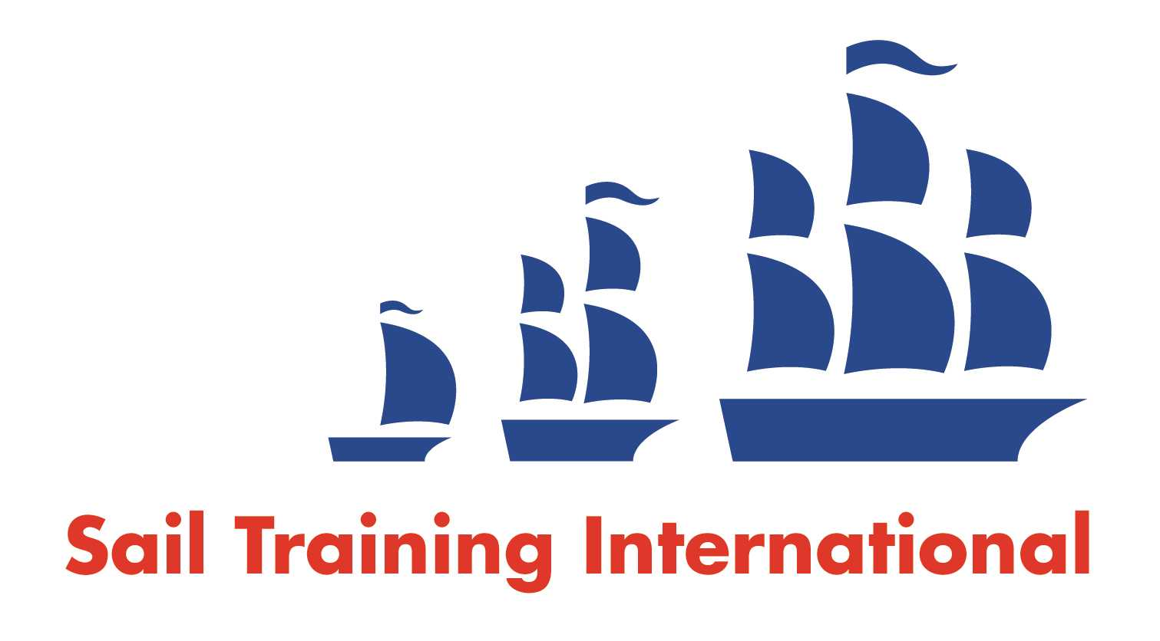
Sail Training International Paid/Volunteer Positions Submission Form

Editorial Policy

- This listing facility is free of charge but will only be accepted from sail training organisations and vessel operators that are members of their national sail training organisation or the Sail Training International Class A Tall Ships Forum.

- STI reserves the right not to publish a listing for any reason whatsoever.

- After completing the form, email to STI (office@sailtraininginternational.org) with copy to your National Sail Training Organisation for editorial review and approval prior to publishing on site.
Date of Posting | April 2018
Name of Vessel | STV “Eye of the Wind”
Organisation Recruiting | Forum train & sail GmbH
Name of Position | Engineer
Location of Position | Hamburg, Germany
Position is | Full Time | x | Rotational | X
Remuneration | Paid | £Contact us to discuss pay rate
Description of Position | The “Forum sail & train GmbH” is inviting applications for the position Engineer on the Brigg “Eye of the Wind”. The position is rotational and preferred starting date the 15th of May 2018.  STCW safety certificates, ENG1 or equivalent, minimum MEOL or higher required. Electrical skills would be a plus.  We are very busy throughout the year and vary our destinations in European as well as Caribbean waters.
Person to Contact | Captain Michael Vogelsgesang
Organisation’s website: | https://www.eyeofthewind.net/en/
Email | onboard@eyeofthewind.net, mvogelsgesang@runbox.com
Telephone | +49 (0) 152 0992 6940
Fax | n/a
Closing Date for applications | When filled

