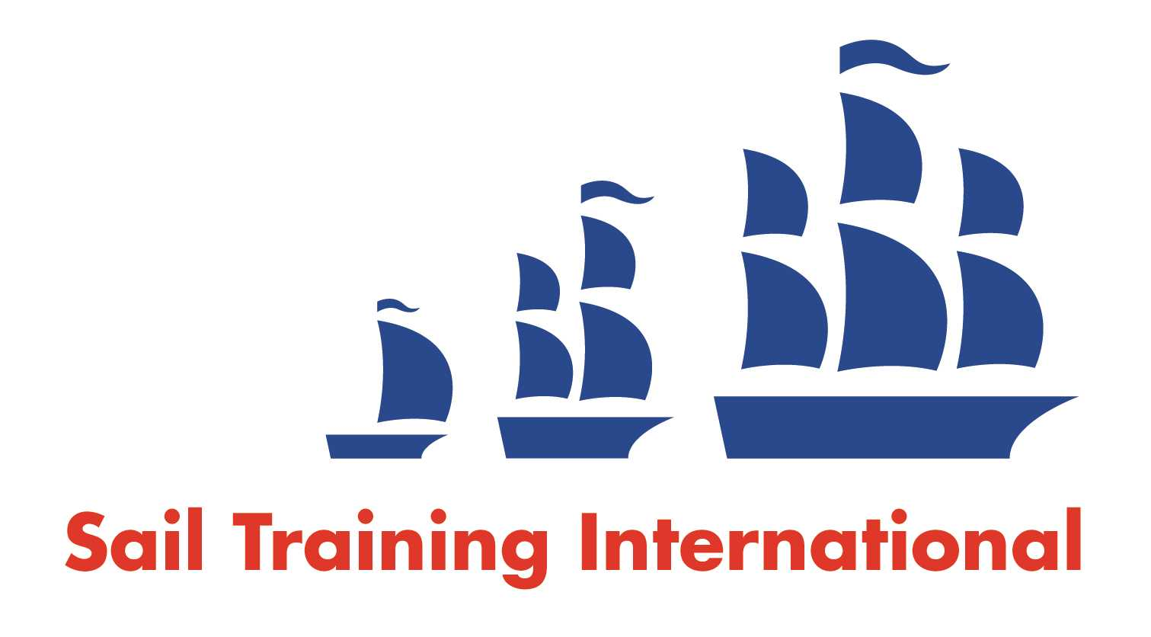
Sail Training International Positions Sought Submission Form

Editorial Policy

- This listing facility is open to any vessel operator or organisation involved in sail training.

- STI reserves the right not to publish a listing for any reason whatsoever.

- After completing the form, email to STI (office@sailtraininginternational.org) for editorial review prior to publishing on site. You can expect your advertisement to appear within 2-3 business days.

- Your listing will be automatically removed after three months unless you indicate an earlier date. To retain a listing beyond three months, please notify STI before the end of the three month period.

Date of Posting | 22/11/17
Name | Jubilee Sailing Trust
Position Sought | Relief Master
Location preference | Worldwide
Full Time / Seasonal  (delete as appropriate) |  | Paid / Voluntary  (delete as appropriate)
Description of Position Sought  (max 100 words) | The Jubilee Sailing Trust (JST) is looking for relief Masters to provide occasional cover on its vessels LORD NELSON and TENACIOUS. The JST is a UK registered charity that promotes the integration between disabled and non-disabled people through tall ship sailing.  The Master is responsible for the overall day to day running of the vessel, its safety and SMS compliance, operational efficiency and the delivery of an exhilarating voyage.
Qualifications | STCW (II/2) Master Yachts <3000gt or Unlimited CoC and associated safety certificates. Prior experience in command on square rigged vessels essential.
Email | Charlotte.butcher@jst.org.uk
Telephone | 02380443113

